Chapter 15: Dynamic Programming
4 steps:
1. Characterize the structure of an optimal solution. then use it to construct an optimal solution to the problem from optimal solutions to subproblems.
2. Recursively define the value of an optimal solution.
3. Compute the value of an optimal solution, typically in a bottom-up fashion.
4. Construct an optimal solution from computed information.

15.1 Rod Cutting
The rod-cutting problem is the following. Given a rod of length n inches and a table of prices pi for i D 1; 2; : : : ; n, determine the maximum revenue rn obtainable by cutting up the rod and selling the pieces. Note that if the price pn for a rod of length n is large enough, an optimal solution may require no cutting at all.
We can cut up a rod of length n in 2n1 different ways,
We say that the rod-cutting problem exhibits optimal substructure: optimal solutions to a problem incorporate optimal solutions to related subproblems, which we may solve independently
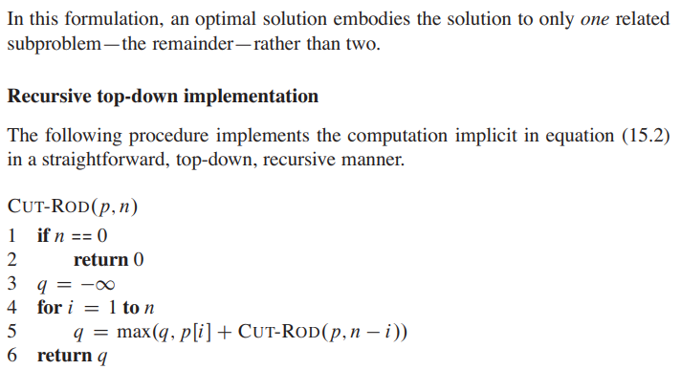
Running time above is O(n)?
Using Dynamic Programming:
Time memory trade off: more space required, but less time because look up
Top-down with memorization: procedure recursively in natural manner, but saves the result of sub problems in hash tables or array
Bottom-up: depends on natural notion of the size of sub problem. solving sub-problem depends on solving smaller sub problems. Order sub problem by size and solve in smallest to largest
p=input array, n =max revenue possible for length n, n=0 means no revenue possible, 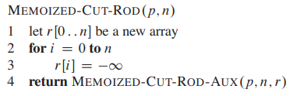
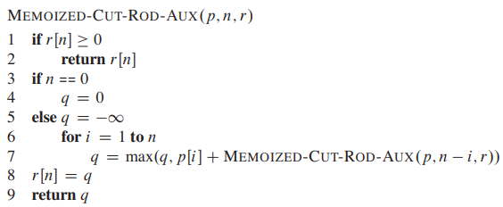
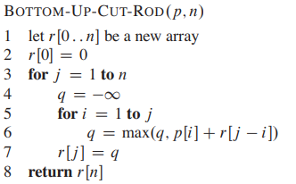
https://www.codesdope.com/course/algorithms-rod-cutting/
https://iq.opengenus.org/rod-cutting-problem/#:~:text=Brute%20Force%20approach,-For%20a%20rod&text=Also%20for%20every%20length%2C%20we,cut%20the%20rod%20or%20not.&text=which%20means%3A,recursive%20function%20max_price(N%2Di).

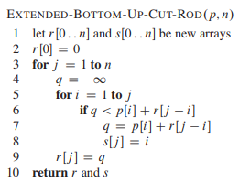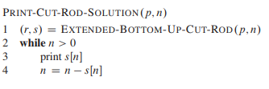
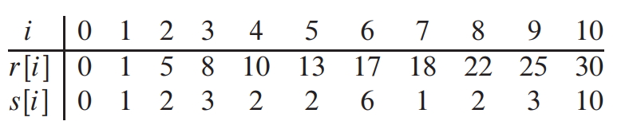
http://ycpcs.github.io/cs360-spring2015/lectures/lecture12.html
Summary of Extended Bottom-Up-Cut-Rod
With array p with prices
R_{i} shows max as determined by getting max of
- Itself (when i=j)
- I is cut (different) and remainder j
- Looks up these values from p array
S_{i} keeps track of length of left side cut, this can be used to get what is left over by getting
-starting length - S_{i} and continuing
Hence the maximum revenue for a rod of length 5 is 16. We can reconstruct the cuts that give this revenue from the s_{i}'s using lines 10-14 of EXTENDED-BOTTOM-UP-CUT which gives
1 (for s₅) ⇒ i = 5 - 1 = 4
1 (for s₄) ⇒ i = 4 - 1 = 3
3 (for s₃) ⇒ i = 3 - 3 = 0
So we should make two cuts of 1 and leave the remaining 3 uncut.
Bolded and italised are sizes of cuts that should be made

15.2 Matrix Multiplication
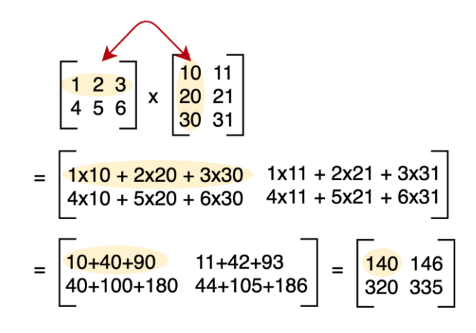
A (2*3)*(3*2) = (2*2)
Note that in the matrix-chain multiplication problem, we are not actually multiplying matrices. Our goal is only to determine an order for multiplying matrices that has the lowest cost.
Brute Force:
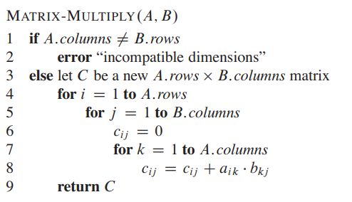
Applying dynamic programming:
Step 1.1: The structure of an optimal parenthesization
That is, for some value of k, we first compute the matrices Ai ::k and AkC1::j and then multiply them together to produce the final product Ai ::j .
Cost of parenthesizing matrices: cost of computing.. (A_{i..k}+A_{k..+j}+multiplying them together)
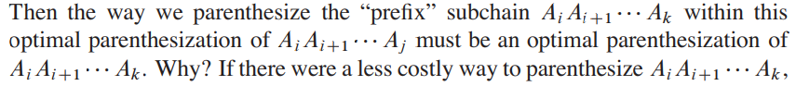
Basically the sub matrices, however they are split, have to be the optimal way of parentification because the sub matrices can be replaced.
Step 1.2: construct optimal solution to problem from optimal solutions of subproblems.
any optimal solution contains within it optimal solutions to subproblem instances. Thus, we can build an optimal solution to an instance of the matrix-chain multiplication problem by splitting the problem into two subproblems
finding optimal solutions to subproblem instances, and then combining these optimal subproblem solutions

Step 2: Recursive Solution (Define cost of optimal solution) pg 395
M[i,j] = minimum number of scalar multiplication needed to computer A_{i..j}
M[1,n] = lowest cost to compute A_{1..n} for the full problem

If (i==j)
- Chain consist of 1 matrix A_{i..i}=A_{i}, scalar multiplication = 0
  - m[i,i]=0
if(i<j)
- m[i,j]= 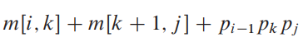
  - min. Cost of computing subproducts A_{i..k}and A_{k+1..j}+p_{i-1}X p_{i}
- we split the product A_{i}A_{i+1} [...] A_{j} between A_{k}and A_{k+1}, where i k
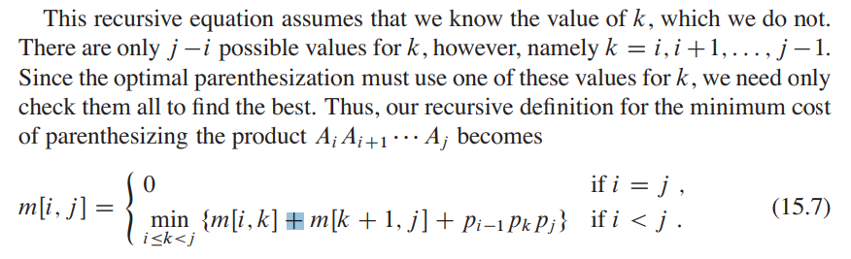
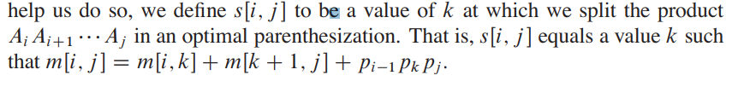
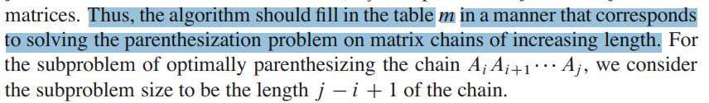
Step 3: Computing the optimal costs
-recursive algorithm takes exponential time o(N^2)
-instead, using a tabular, bottom-up approach
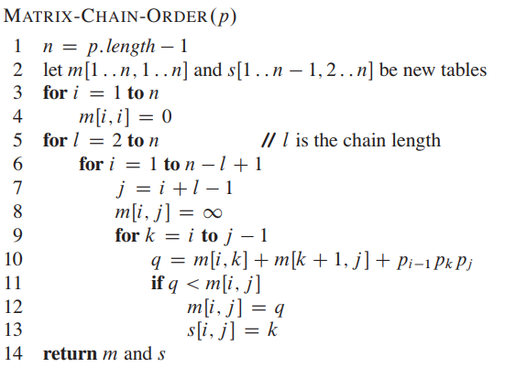

Line | What it’s doing
3-4 | -computing m[i,i]=0
First loop of 5-13 | =2..n  =1..5(6-2+1),2..5,3..5,4..5  -i=first num of above, j=i+length of chain(6)-1  -line 7 = set m[i, j]=infinity  Comput min. Cost for chain length l=2, m[i,i+1]  -m[1,2],m[2,3],m[3,4],m[4,5]=infinity
Second loop of  5-13 | =3..n  =1..4(6-3+1),2..4,3..4  Comput min. Cost for chain length l=3, m[i,i+1]  -m[1,3], m[2,4], m[3,5]=infinity
 | -m[1,4],m[2,5], m[1,5]=infinity

O(n^3) running time

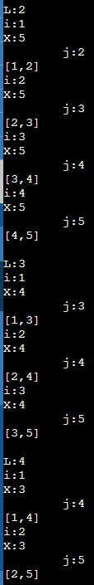
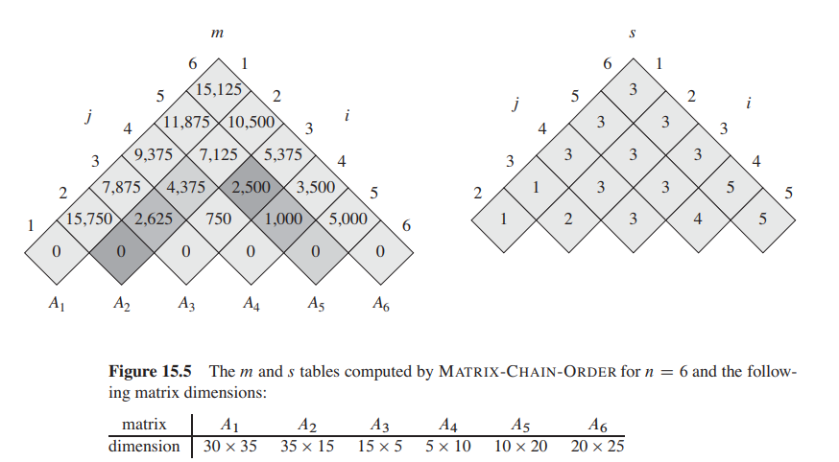
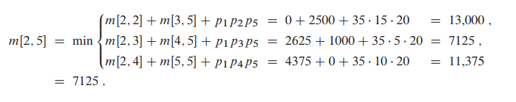

Step 4: Constructing an optimal solution
-determines the optimal number of scalar multiplications needed to compute a matrix-chain product
-s[i,j]=records a value of k such that an optimal parenthesization of A_{i}A_{i+1}…A_{j}
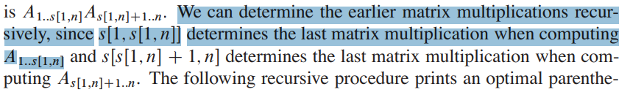
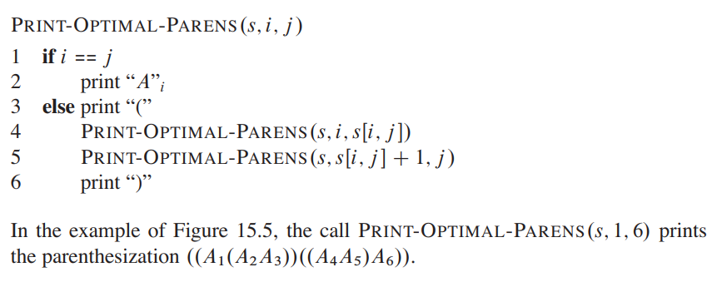

15.3 Elements of Dynamic Programming
1.Optimal Substructure: characterize it
Common Patterns
- Making choice leave one or more subproblems
- Assume choice leads to optimal solution
- After choice, determine which subproblems happen and how to best characterize the resulting space of subproblems
- Cutout non-optimal solution to each such problem with optimal one
- Sub-problems independent of each other
Running Time depends on
- number of sub-problems overall
- How many choice looked at for each subproblem
2. Overlapping subproblems: When a recursive algorithm revisits the same problem repeatedly, storing the solution in a table where it can be looked up when needed
- Reconstructing an optimal solution
- Memoization
  - A memoized recursive algorithm maintains an entry in a table for the solution to each subproblem
Rod-cutting
N sub-problems
N choices to make
O(N^2) running time

Matrix Chain Multiplication:
n^2 sub-problems
N-1 choices
O(N^3)
if all subproblems must be solved at least once, a bottom-up dynamic-programming algorithm usually outperforms the corresponding top-down memoized algorithm

412

15.4 Longest Common Sub-sequence

Given two sequences X and Y , we say that a sequence Z is a common subsequence of X and Y if Z is a subsequence of both X and Y . In the longest-common-subsequence problem, we are given two sequences X D hx1; x2;:::;xmi and Y D hy1; y2;:::;yni and wish to find a maximumlength common subsequence of X and Y . This section shows how to efficiently solve the LCS problem using dynamic programming.

-longest sequence of matching letter in both strings, do not have to be in same placement

15.5 Optimal Binary Search Tree<-

400-435
Chapter 16: Greedy Algorithms
16.1 Activity Selection Problem
Our first example is the problem of scheduling several competing activities that require exclusive use of a common resource, with a goal of selecting a maximum-size set of mutually compatible activities.
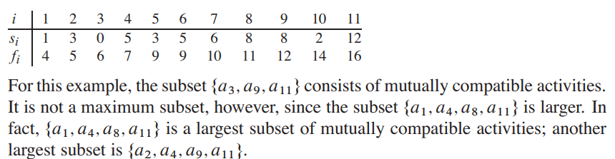
441-472
Index k
S -start array
F- finish array
N - size of original problem.
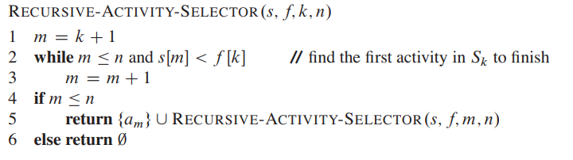
(s,f,0,11)
s,f,k,n
Line 2-3: go through 1-11 (m) and start[m]<f[0](null)
-nothing first then go to line 4
Line 4: 1<=11
Line 5: (s,f,1,11)
—-
m=2, from 2-11 and s[2-11]<f[1](1)
- First s[2](3)<f[1](4)
- Continue
- -s[3](0)<f[1][4]
- s[4](5)<f[1](4)
- Quit, m=4
- Line 5: (s,f,4,11) //,=k+1
Summary: for every finishing time starting at the first index, find the index of start of next activity that starts after. Once you have that use start of next activity’s finishing time to find start of activity after that.

(s,f,0,11)
->line (s,f, 1, 11)
-finishing time of 1=4, find item next with start time that is greater than 4, which is index 4
-index 4, s[4]=5, f[4]=7=k
-> line (s,f,4,11)

-finishing time of 4=7, find item next with start time that is greater than 7, which is index 8
-index 8, s[8]=8, f[8]=11=k
->line (s,f,8,11)
-finishing time of 8=11, find item next with start time that is greater than 11, which is index 11
-index 11, s[11]=12, f[11]=12=k
-return 0
Iterative version of above

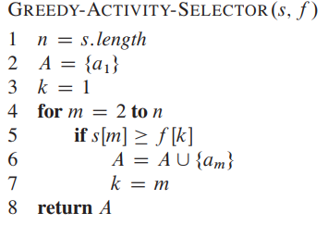
Line 1-3:
n=lenghth (11)
A=initialize activity
k=1, index to activity

For 2-11
{
If start of num above is greater than finish time of k (which is initially f[1]=4)
=to check (in line 5) that its start time sm is not earlier than the finish time fk of the activity most recently added to A
-add activity to A
-set k to m, set new index to start
}

Summary of above: while iterating through array, add a_{m} (largest possible set) to answer set if starting time is less than designated finishing time, if added, update new finishing time to index

16.2 Elements of Greedy Algorithm
To develop above…
1. Determine the optimal substructure of the problem.
2. Develop a recursive solution. (For the activity-selection problem, we formulated recurrence (16.2), but we bypassed developing a recursive algorithm based on this recurrence.)
3. Show that if we make the greedy choice, then only one subproblem remains.
4. Prove that it is always safe to make the greedy choice. (Steps 3 and 4 can occur in either order.)
5. Develop a recursive algorithm that implements the greedy strategy.
6. Convert the recursive algorithm to an iterative algorithm
To develop Greedy Algorithms in general
1. Cast the optimization problem as one in which we make a choice and are left
with one subproblem to solve.
2. Prove that there is always an optimal solution to the original problem that makes
the greedy choice, so that the greedy choice is always safe.

How to tell when to use Greedy choice property:
- Greedy Choice Property: make the choice that looks best in the current problem, without considering results from subproblems
- Optimal Substructure: optimal solution to the problem contains within it optimal solutions to subproblems
  - how we demonstrated in Section 16.1 that if an optimal solution to subproblem Sij includes an activity ak, then it must also contain optimal solutions to the subproblems Sik and Skj .
  - argue that an optimal solution to the subproblem, combined with the greedy choice already made, yields an optimal solution to the original problem. prove that making the greedy choice at every step produces an optimal solution.

Dynamic programming | Greedy Algorithm
-make a choice at each step, but the choice usually depends on the solutions to subproblems  -typically bottom up: progressing from smaller subproblems to larger subproblems  -can do top-down, but require memoization  +we still must solve the subproblems before making a choice  -overlapping sub-problems | -makes its first choice before solving any subproblems.  -make whatever choice seems best at the moment and then solve the subproblem that remains  - depend on choices so far, but it cannot depend on any future choices or on the solutions to subproblems.  -making one greedy choice after another, reducing each given problem instance to a smaller one.

0-1 Knapsack
Notice Dynamic Programming vs Greedy
0-1
-n items
-ith item has v_{i} worth and w_{i} weight
-carry only W amount of weight
+fractional knapsack: can take fractions of items
-greedy for fractional, but not for 0-1

Optimal substructure: If we remove item j from this load, the remaining load must be the most valuable load weighing at most W wj
-we must compare the solution to the subproblem that includes the item with the solution to the subproblem that excludes the item before we can make the choice

Fractional Knapsack
-Greedy can be done
Steps to solve Fractional Knapsack
- Computer value per pound v_{i}/w_{i}
- Taking item with the greatest value per pound, if room left continue taking until Weight limit W
- Sort per pound O(n lgn)
16.3 Huffman Code
Huffman’s greedy algorithm uses a table giving how often each character occurs (i.e., its frequency) to build up an optimal way of representing each character as a binary string
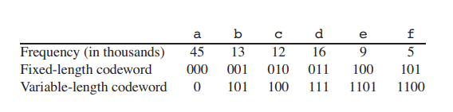
Binary character code: each character is represented by a unique binary string
Codeword: unique binary string
Fixed-length code: fixed amount of bits to represent characters XXX
Variable length code: giving frequent characters short codewords and infrequent characters long codewords
prefix codes: codes in which no codeword is also a prefix of some other codeword
- can always achieve the optimal data compression among any character code
Encoding: concatenate the codewords representing each character of the file.
we code the 3-character file abc as 0*101*100=0101100, where “*” denotes concatenation.

(a) The tree corresponding to the fixed-length code a = 000, ..., f = 101. (b) The tree corresponding to the optimal prefix code a = 0, b = 101, ..., f = 1100.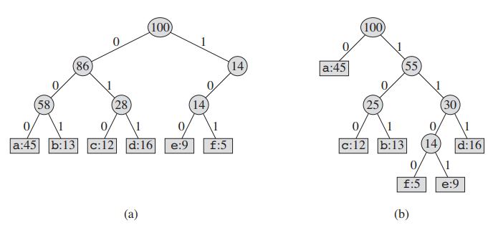
repeat the decoding process on the remainder of the encoded file
-In our example, the string 001011101 parses uniquely as 0 * 0 *101* 1101, which decodes
to aabe.
-fixed length represented with not optimal
-variable length represented with full binary tree, non leaf tree has two nodes

the tree for an optimal prefix code has exactly |C| leaves, one for each letter of the alphabet, and exactly |C| 1 internal nodes

For each character c in the alphabet C, let the attribute
c.freq denote the frequency of c in the file
-d_{T}(C) denote the depth and length of codeword for character c

number of bits required to encode a file
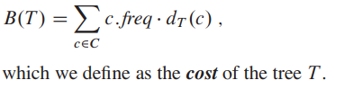
Sum of all letters frequency times their length of the codeword for character c
-the greedy-choice property and optimal substructure

Notes:
C is a set of n characters
N is number of characters
C.frequency is frequency of character
T tree in bottom up manner

-Begins with set of C leaves
-C is alphabet, c is letter in alphabet
-C-1 merging operations to create final tree
-min-priotiy queue Q, with frequency attribute
-Merge causes two object to turn to one object whose frequency=sum of frequencies
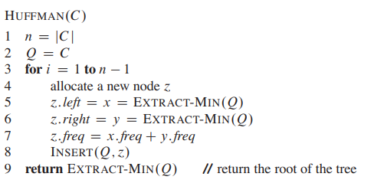
Line 1: Initial queue n=6 b/c 6 letters
Line 2: Q= intitalize empty min-prioty queue
Line 3: For 1- size-1 (1-5)
Line 4-8: node created, extracts two min leafs and adds them
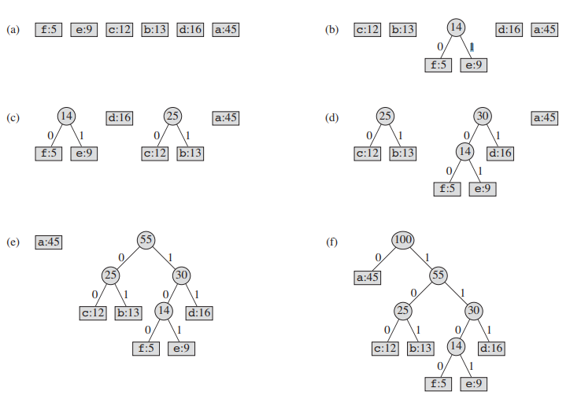
Run time of Huffman:
-o(n) to build min-heap
-o(lgn) heap operation
-total: o(nlgn)
-possible reduction with Emde Boas Tree: O(lglgn) Chapter 20
454 proofs
Lemma 16.2 (Greedy Choice Proof)
Lemma 16.3 (Optimal prefix codes)

16.4 Matroid
16.5 Task Scheduling with Matroid

